A Rock Garden Newsletter June 2019 ====================================================================================

The Gardens of Rice Creek
A Place of Beauty by Steve LaVallee
Several years ago while visiting my daughter in Minneapolis, I decided, on a whim, to do a Google search for an old favorite nursery, Rice Creek Gardens. Rice Creek Gardens was operated by Betty Ann Addison and located in Blaine, Minnesota, a suburb to the north of Minneapolis. At the time, the area was somewhat rural and Rice Creek Gardens occupied five acres filled with perennials, trees, shrubs, and most importantly, an incredible selection of alpine plants. They had a mail order catalog, but every year, and sometimes twice a year, my mom would ask me to drive her to Rice Creek Gardens. She would drive from Milwaukee to Friendship, in central Wisconsin where we lived, and the next morning the two of us would make the slightly over three hour trip to Rice Creek Gardens. My mom would bring the mail order catalog marked up and highlighted with all the plants she wanted to buy. We always spent several hours at Rice Creek Gardens

walking through the beautiful gardens and landscape, perusing the plants for sale and eventually we would head back home, usually several hundred dollars poorer but enriched by the experience. For many years this was a special trip and even more so now that my mom is no longer able to ride along.
Then suddenly there was no mail order catalog and eventually Rice Creek Gardens closed. It appears that as the area transformed from a somewhat rural area to a long stretch of highway filled with big box stores and strip malls, the nursery couldn’t be maintained. It was a great disappointment to no longer have Rice Creek Gardens and their large selection of unique alpine plants available. I especially missed the opportunity to make this trip with my mom who was the major and most significant influence regarding my interest in gardening.
The availability of alpine plants either in nurseries or through mail order has significantly dwindled over the last few years

although we are extremely fortunate to have the Flower Factory in our area. LaPorte
Avenue Nursery, Siskiyou, and Mt. Tahoma Nursery, to name a few, were wonderful
resources for alpine plants and dwarf shrubs. These nurseries and others either no longer exist or do mail order business. I was fortunate and simply by fate happened to be in the state of Washington several years ago, the last week Mt. Tahoma Nursery was open. I had a wonderful visit with Rick Lupp at the nursery and he wanted to be sure, as I shared with Ed, that it be known he sent his best to everyone in the WI-IL chapter. In addition to sharing his incredible knowledge as we toured his gardens and greenhouses, all of these unique and wonderful plants were on sale for fifty percent off. Mistakenly, I grabbed some plants from his propagation and stock greenhouse which were quickly returned. In hindsight, I somewhat facetiously think it would have been a great idea to rent a trailer and fill it with all of these plant gems. Instead, I was only able to fill the small area in the trunk that didn’t have luggage, as well as beer and wine from the region (we need something to enjoy when done working in the gardens) with plants.

My Google search for Rice Creek Gardens brought a welcome surprise, namely a link for “The Gardens of Rice Creek”. I was excited to learn that Betty Ann had relocated to Fridley, which is just to the northwest of Minneapolis. I was further excited to learn that the nursery would be open the next day.

I arrived just as the nursery was opening around 9:00am. I was greeted by Betty Ann who took me on a guided tour of the grounds including the property across the street where, in addition to many woodland plants, it is the site for the propagation and

hybridizing of rhododendrons. Many of these are unique to the Gardens of Rice Creek.
B Betty Ann is extremely knowledgeable and very willing to share information. Suffice to say, I learned a lot.

The grounds are on four levels and feature a waterfall in between. It would be difficult to list all the plants in the gardens but there was a variety dwarf conifers, rhododendron, shrubs, primroses and numerous other alpine plants. My visit was at a time when the lady slippers were in bloom. They were stunning with too many to count in shades of pink and white as well as yellow growing among other woodland plants. I would strongly suggest visiting at a time when the lady slippers are in bloom as it is truly spectacular.

The other highlight of the visit was the ability to purchase plants. Betty Ann has a wonderful variety of plants for sale of which again, there are too many to list. A favorite was the double anemonella including both “Shoaf’s Double Pink” and “Cameo”. They are currently blooming in the garden at home and are a favorite. There are also a great variety of rhododendron and dwarf conifers for sale in addition to the alpine plants. I would note that all of the plants are very reasonably priced and it was very easy to fill the car. The website has a listing of plants: http://www.gardensofricecreek.com/nursery.htm.

The Gardens of Rice Creek are only open on Saturdays, from 9:00am through 4:00pm, through Labor Day or by appointment. They are located at 1315 66th Ave. N.E. Minneapolis, (Fridley) MN (763-242-5009). Each weekend there is a featured plant variety. Rock Garden Days are May 11th and 9th and Ladyslipper Days are June 8th and 15th.

While it is a bit of a drive, it is a very worthwhile trip. The beautiful gardens and the ability to purchase some very unique plants as well as a very gracious and knowledgeable host, make for a great day at the Gardens of Rice Creek.

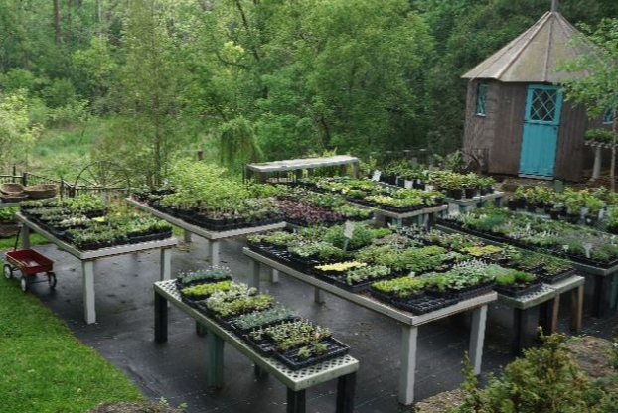

There are other gardens to visit in the area, some of which are listed below. We visited the Como Park Zoo and Conservatory in January, and while the outside gardens were covered in snow, the indoor domes were a wonderful respite from the cold. The Japanese garden is supposed to be a highlight.

Other Area Gardens to Visit

University of Minnesota Arboretum - http://www.arboretum.umn.edu/
The Minnesota Landscape Arboretum features 1,137 acres of natural areas, public gardens and thousands of plant labels designed to inspire ideas for visitors' own backyards. With specialty gardens, demonstration areas, and more than 5,000 plant species and varieties, the Arboretum has become one of the premier horticultural
field laboratories and public display areas in the country.

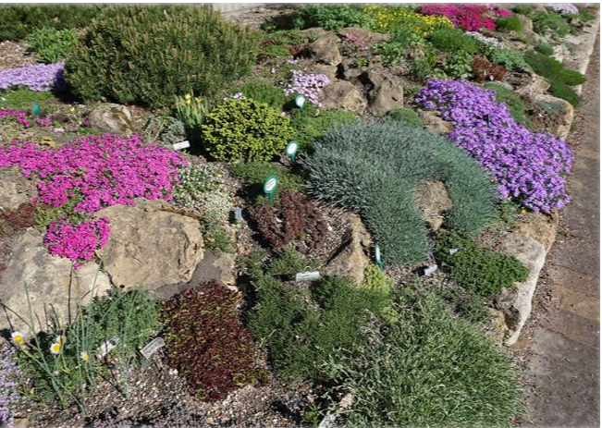

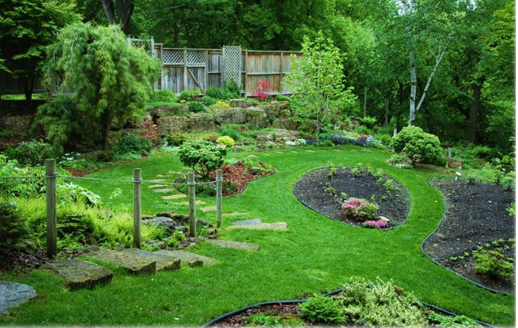

Como Park Zoo and Conservatory - http://www.comozooconservatory.org/attractions/gardens/japanesegarden/#/info

- The home of many different gardens including the Charlotte Partridge Ordway Japanese Garden. In addition to the outdoor gardens there are a number of indoor gardens and domes featuring many interesting plants including a wonderful orchid house.

Public Gardens of Minnesota - https://mngardens.horticulture.umn.edu/
This site has a listing of all public gardens in the state. The “View by Region” tab will take you to a listing for “Metro Area” which lists public gardens, in addition to those noted above, in the Minneapolis area.

Our June meeting will be Saturday, June 15, and we will join Iza Goroff working in the rock garden at Rotary Gardens at 1455 Palmer Dr. We start at 9, or whenever you can arrive, and work until about noon. Then we reconvene at a nearby restaurant for lunch paid for by the chapter. This is always a fun time to catch up with fellow members and admire the Rotary Garden plantings.

All articles relating to gardening in some way are welcome, no matter how long or short! As you garden or visit this summer, please consider sharing your thoughts with other members. Send them to jahalve123@gmail.com.

2019 Chapter Officers
Chairperson Damon Smith 1302 Troy Dr, Madison, WI 53704. (608) 335-0336, damonsmith56@hotmail.com
Vice Chair Dave Collura 13600 W Graham St, New Berlin WI 53151 (262) 789-1394, nargsbooks@gmail.com
Secretary Lynn Groeschel W12464 Boots Road, Wisconsin Dells, WI 53965 (608-697-3005) lsgroeschel@gmail.com
Treasurer John Mather 6524 County Rd K Blue Mounds WI 53517 (608) 795-4636 mrjcmather@gmail.com
Editor/Membership Jean Halverson 1111 N. Johns St. PO Box 101 Dodgeville, WI 53533 (608) 935-3721, jahalve123@gmail.com

